PERSONALIZED E-LEARNING COURSE RECOMMENDATION SYSTEM
Scope and Limitations
Department of Computer Science and Engineering, [COLLEGE NAME]
Batch C7 (CSE-C) · Academic year [ACADEMIC YEAR]
Table 1: Project team
S.No. | Student name | Roll number
1 | PITTALA AKHILA | 23K91A05J3
2 | MUNDALA SANDHYA | 23K91A05G5
3 | MULA THANUJ REDDY | 23K91A05G4
4 | MAJJIGAPU JAGADESHWAR REDDY | 23K91A05E1

Project guide: K GAYATHRI
Chapter and section numbers quoted in the text (for example Section 6.6 or Chapter 8) refer to the full project report, 17.Final Document. Figures and tables in this document are numbered from 1.

1. SCOPE

1.1 In scope
The system covers one complete loop: a learner registers, describes themselves, receives an explained ranking, acts on it and sees the ranking change. The table lists each capability and where it is delivered.
Table 2: In scope
# | Capability | Delivered by
1 | Learner accounts with a stored ten-field profile (education, skill level, interests, preferred topics, goals, preferences, learning style, weekly hours, age band, gender) | users, profiles tables; /api/auth/*, /api/profile
2 | A 24-course catalogue in 9 categories with topic, level, duration, difficulty, prerequisites, outcomes, tags, format and rating, searchable by text, category and level | courses table seeded from data/catalog/courses.json; /api/courses
3 | Content-based matching of the learner's text to course text (TF-IDF cosine) plus skill, topic and goal terms | app/recommender.py: content_scores, skill_compat, topic_interest_score
4 | A hybrid eight-term ranking with match percentage and reasons on every card | rank_courses; /api/recommendations
5 | Feedback events (nine types) that change the next ranking at once | interactions table; behavioral_boost, engagement_level; /api/interactions
6 | A learner-success estimate and an estimated benefit for five learning actions, shown as a suggested next action | Success model and T-learner bundle in models/*.joblib; predict_success, uplift_scores
7 | A staged learning path of up to six courses ordered by skill level and then score | /api/learning-path
8 | Insights, activity log, recommendation history and a model-analytics area (model table, confusion matrices, offline policy values, fairness audit) | /api/insights, /api/activity, /api/history, /api/metrics, /api/fairness
9 | Tests and checks | 5 pytest tests, 33 smoke checks, a responsive check at 360, 768 and 1440 px

1.2 Out of scope
Table 3: Out of scope
# | Item | Why it is out
1 | Collaborative filtering across learners (objective 3) | No log of many learners' course histories exists; the behavioural term is per learner
2 | The real OULAD data | Never downloaded or used; the models are trained on a reproducible synthetic stand-in
3 | The base paper's Actor-Critic agent and causal regularisation | Not implemented; only uplift scoring, off-policy evaluation and a fairness audit are borrowed
4 | Prerequisite graphs or knowledge tracing | Prerequisites are stored as text and shown, not used to order the path
5 | Live experiments and user studies | No A/B test, no learner feedback collected, no precision/recall against real feedback
6 | Production operation | No cache, single SQLite file, local demonstration authentication, no containers, monitoring or load handling

The boundary is deliberate. The system is a demonstrator of an explainable recommendation loop on synthetic data; anything that would make claims about real learners or real platforms is outside the project.
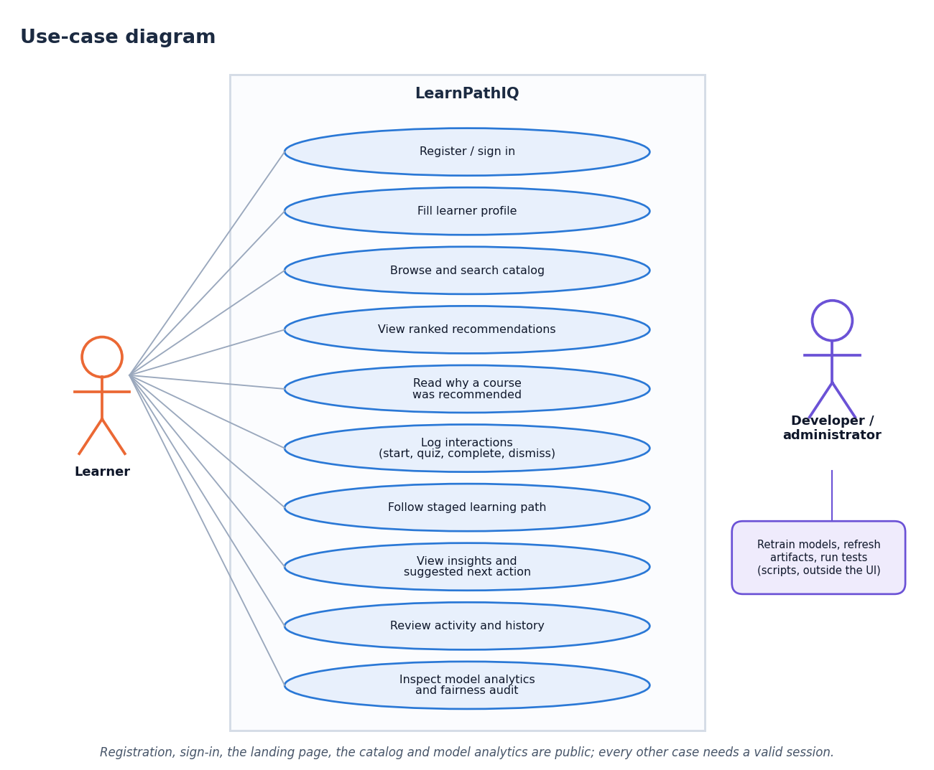
Figure 1: What the user can do within the scope of the system (use-case diagram)

2. ASSUMPTIONS
Table 4: Assumptions and what happens if they fail
# | Assumption | If it does not hold
1 | Learners type interests and goals as English free text | The TF-IDF term (English stop words, no stemming) loses most of its signal; other terms still rank
2 | The 24-course hand-written catalogue stands in for a real platform's catalogue | Precision figures on the persona check do not transfer to a larger or noisier catalogue
3 | The synthetic generator reproduces the shape of an online-learning log (weekly clicks, quizzes, forum posts, an outcome) | All success, uplift and policy numbers are only about the generator, not about real learners
4 | Event weights, score weights and limits are reasonable hand-set constants | Rankings could be improved by tuning; the ablation shows two terms that do not help on the persona set
5 | One trusted user group on one machine | The token authentication and single SQLite file are not an identity or multi-user design
6 | Python 3.11 or newer, Node.js 20 or newer and a modern browser are installed | The back end or the React front end will not start; the original Jinja pages need only Python

3. LIMITATIONS
Each limitation below is backed by a measurement in this project; none is a generic disclaimer.
Table 5: Limitations with their evidence
Limitation | Evidence | Consequence
Synthetic training data | Real OULAD never used; label generated by train_pipeline.py | No external validity; results show recovery of the generator's rule
Weak predictive signal | Test AUC 0.603 (six-seed mean 0.614); with the hidden assessment score 0.800 | The success term in the score is a weak signal; accuracy is a few points above the majority rate
Weak policy evidence | IPS 0.0088, SNIPS 0.6652, DR 0.4355; effective sample size 9.1 of 2,640 | No conclusion about the action policy can be drawn
No collaborative filtering | Objective 3 not met | The system cannot learn from other learners' histories
Hybrid does not beat content-only | P@3 0.733 vs 0.800; P@5 0.54 vs 0.56 | Extra terms add adaptation and cold-start safety, not persona-level precision
Unstable action advice | Quiz benefit +0.091 to -0.180 after six events; best action quiz to homepage | Estimates are not causal and must not steer real decisions
Same suggested action on every card | Action depends only on learner state, not on the course | The per-card action line carries no course-specific information
Fairness gap | F1 0.305 for age 55+ against 0.415 for 0-35 (n = 204) | Weaker success prediction for the smallest, oldest group; no mitigation applied
Empty contributing-features list | predict_success() returns importances only for models with feature_importances_; the deployed logistic regression has none | The Insights page cannot show per-feature contributions; coefficients are visible only in the analytics plot
No real feedback | No precision/recall from learners, no user study | Objective 6 only partly met
Demonstration-grade engineering | No cache; one SQLite file; tokens are not expired server-side (the 72-hour limit is the cookie lifetime only) | Not suitable for shared or production use

Table 6: Risks and mitigations
Risk | Mitigation in the project
Suggestions mistaken for educational advice | Interface text states that action scores are estimated benefits, not proven effects, and that offline estimates are not a live test
Over-trust in a weak model | The analytics page shows the real test metrics and the dataset name; the policy page carries the not-a-live-test notice
Opaque ranking | Every card shows a match percentage and reasons; the score weights are documented and ablated
Unauthorised access | Hashed passwords (PBKDF2-SHA256), random 256-bit tokens, HttpOnly cookie; 401 on protected routes (tested)
Bad input | Pydantic validation (422), unknown event types rejected (400), unknown course 404 (tested)

4. WHAT WAS NOT MEASURED
The following were not measured and are therefore stated as gaps, not estimated:
• Any result on real OULAD or any other real learner data.
• Precision, recall or relevance ratings from real learners; any user study or usability study.
• A live A/B test of the suggested action or of the ranking.
• The sensitivity of the offline policy values to the propensity clip (0.02 to 0.98) and the weight cap (10), which were fixed.
• Tuned or learned score weights; the eight weights are hand-set and only ablated.
• Load, concurrency and long-running behaviour: latency was measured with one client making sequential requests.
• Browsers other than Chrome, assistive technology, and any penetration test.
• Confidence intervals for the persona-check precision: ten personas on a 24-course catalogue are too few.

